Steps For Populating a Project In Integrity Release 10

Only two things need to be in place in order to begin this effort: the Administrators have been asked to build the project repository on the production server, and the project’s directory hierarchy (folders/files) has been defined and properly structured. This last item is important because Integrity views each project as a structure of projects and subprojects so that the folders in your project directory hierarchy are treated as subprojects in Integrity. This allows you to build more targeted, granular sandbox definitions.

Once the above two items are complete launch Integrity and select Project / Open Project.

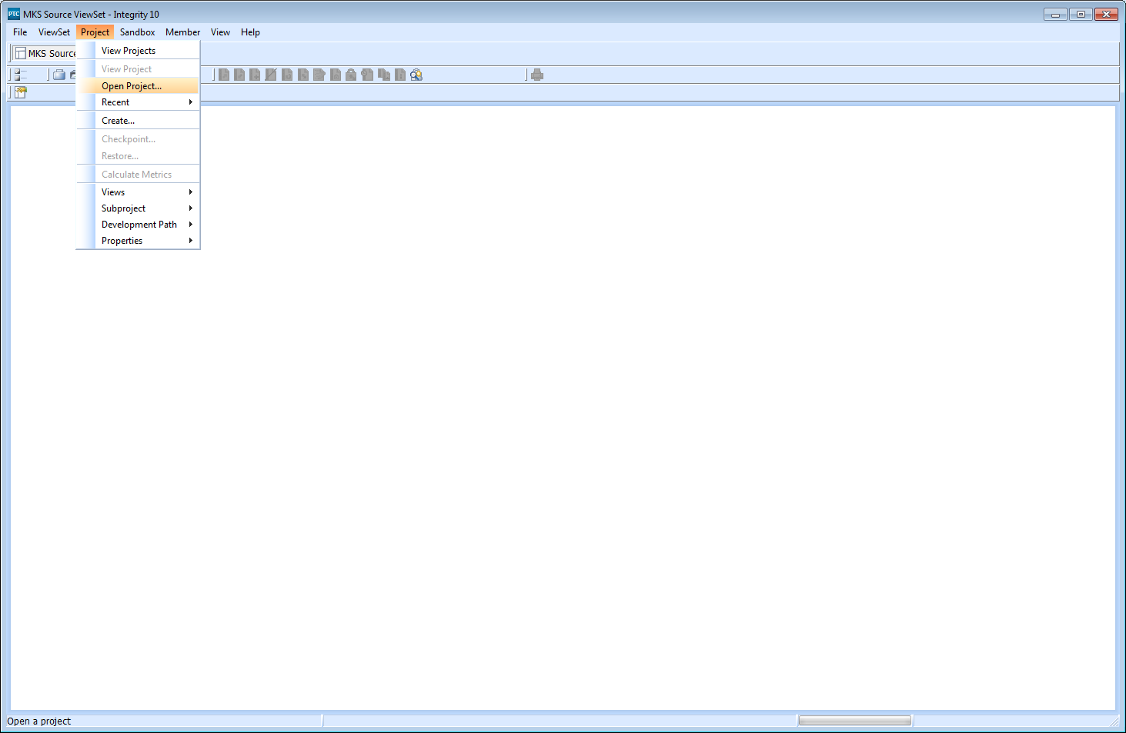

After connecting to the server, the Project Wizard comes up:

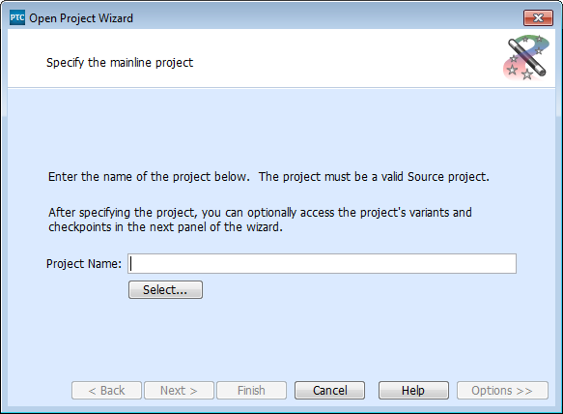

Choose Select and click on your Project location and click OK, and then Finish.

In the new “Project” window, right-click on the top line in the window and select Create Sandbox.

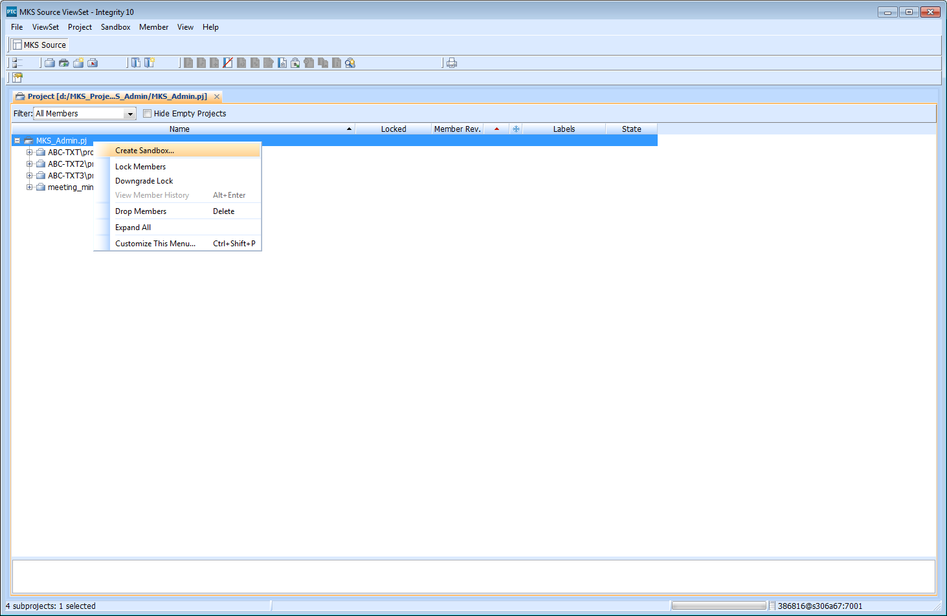
This brings up the Sandbox Wizard, from which you click Browse:

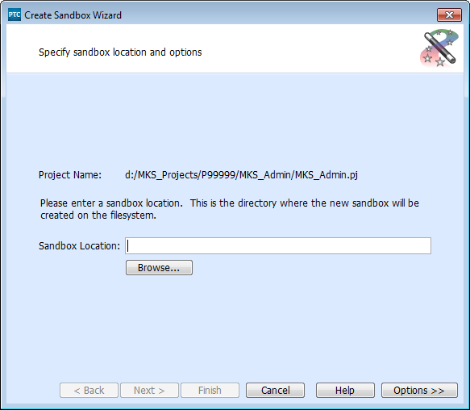

From the Browse window, scroll down to the location of your project’s directory structure and files. (The top level folder should be the same name as the project created by the Administrators.)

Click OK then Finish and Integrity will create the ‘sandbox’ location which will be used to load the project on the server.
From the new “Sandbox” window, right-click the top line and select “Add Members”.
This will bring up the Add Members Wizard, from which you select the “Add Directory…” option.

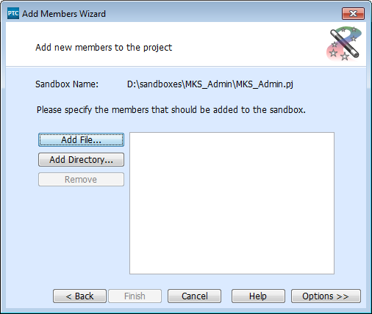

From the Browse window, select a directory to add and click OK. It you have multiple directories to add, simply click “Add Directory…” again and repeat the above process for each one.

Once the directories are chosen be sure to click and open the Options button. Then, CHECK the boxes for “Recurse into Directories” and “Create Subprojects”:

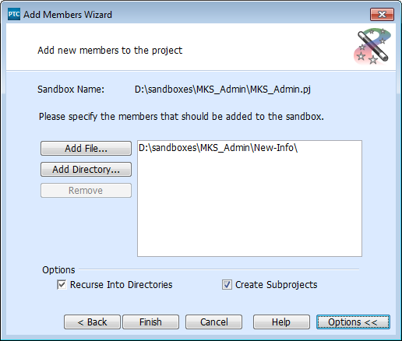

Then click Finish. Enter an “Archive Description” then click OK and Integrity will process your directory hierarchy and all members into its internal format and load the Production Project Repository Server with the contents.

When completed, the project’s files will be available to all registered team members to create their own personal sandboxes against.

